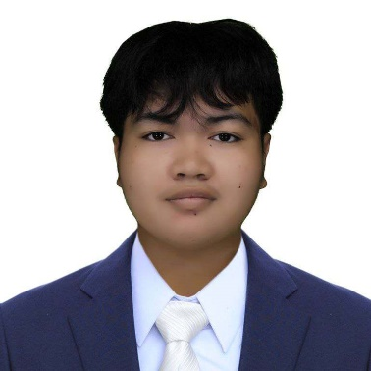**MARK DARYL M. MAG-ASO**

Address: 1721 New Antipolo St. Sta Cruz Manila

Email: darylmark159@gmail.com

Mobile/Phone Number: 09927641601

**CAREER OBJECTIVE**

Dedicated professional looking for opportunity for advancement in a challenging environment. Proactive and prepared to make an important contribution to projects. Committed to continuous learning and having a big influence on the performance of teams and organizations.

**SKILLS**

* Knowledgeable in computer literacy with a solid understanding of basic programming languages including C++, JavaScript, PHP, Visual Basic, HTML, and CSS.
* Familiar with basic editing tools such as Canva, CapCut, and Photopea, with the ability to perform simple editing tasks.
* Experienced in Microsoft Office Suite including Word, Excel, and PowerPoint for creating and editing documents, spreadsheets, and presentations.

**EDUCATIONAL BACKGROUND**

**SECONDARY EDUCATION (Senior High School)**

Arellano University - Juan Sumulong Campus 2600 Legarda St. Sampaloc, Manila

Information and Communication Technology (ICT)

(2022 - present)

**Junior High School**

Cayetano Arellano High School

Teodora Alonzo, Santa Cruz, Manila, 1008 Metro Manila

(2018 - 2022)

**PRIMARY EDUCATION (Elementary)**

Padre Gomez Elementary School

1224 Pedro Guevarra St, Santa Cruz, Manila, 1000 Metro Manila

(2012 - 2018)

**CHARACTER REFERENCE**

Mr. Peejay P. Santiago Mr Edward Eboña Anna Corinne M. Maguddayao

Professional Teacher Professional Teacher Professional Teacher

09777364685 09081513315 09777079984

I hereby certify that all information about are true and correct.

_________________________

Applicant’s Name & Signature